Session 3
- Declare variables for a Flipkart product: productName (as a string), price (float), and rating (double). Assign sample values and print each variable with its data type.
Answer:-
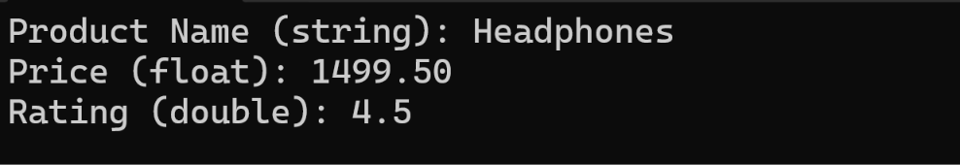

- Create a constant variable to store the GST rate (for example, 18%) and use it to calculate the final price of a Zomato order with a given base price. Constraint: The GST rate must not be changeable after its initial assignment.
Answer:-
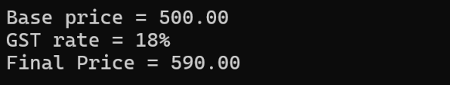

- Write a program that stores your favorite Spotify playlist's name (string), total number of songs (int), and average song duration in minutes (float). Print all values in a single formatted sentence.
Answer:-
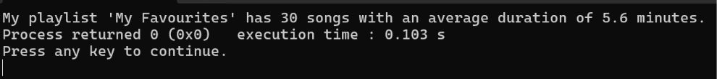

- Identify and correct the invalid variable names from this list: 1stPlayer, player_age, $score, total-marks, username. Hint: Apply standard variable naming rules for your programming language.
Answer:-
Variable name | Valid or Invalid? | Correct name
1stPlayer | Invalid | firstPlayer
player_age | Valid | player_age
$score | Invalid | score
total-marks | Invalid | total_marks
userName | Valid | userName

Rules to remember:
- A variable name cannot start with a number.
- It can contain letters, numbers, and underscores (_).
- Spaces and special characters such as $ and - are not allowed.
- C is case-sensitive, so price and Price are different variables.
- Variable names cannot be C keywords such as int, float, or return.

